Name: _______________________________________ HOMEWORK
Directions: Check the box once you complete the homework activity. Challenge yourself and complete the two bottom optional activities.
This Homework and Baggy Books are due Friday, April 22, 2022
Sight Words  Practice reading your assigned sight words as often as possible. If you are done reading your sight words, work on spelling them! | Word Work  Practice your weekly phonics words. Choose an activity from the phonics choice board.  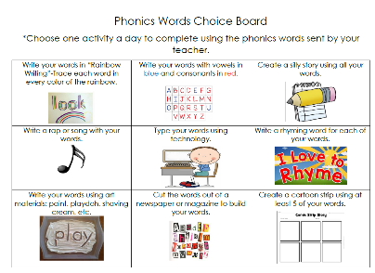  Look on the back for this week’s focus.
Technology Time  Complete at least 20 minutes on Headsprout,  or Dreambox Learning.  This Photo by Unknown Author is licensed under CC BY-SA | Reading  Read your Baggy Books and record them on your Reading Log.
Enrichment – Phonic Fluency  Read a book with a parent. Hunt for words with vowel teams as you read your book. How many words can you find with vowel teams? Include words with long vowel sounds (ee, ea, ai, ay, oa, ue, ie, igh, oo,) as well as r-controlled vowel sounds (ear, eer, ar, er, or, ir, ur, are, air). Also include our new sound ow. List your words and highlight the vowel teams. | Character Corner- BRAVE  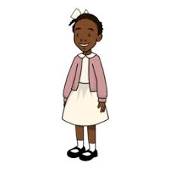  Learn about Ruby Bridges and how very brave she was. Have you ever had to be brave? Talk to your parent about a time that you were afraid and had to be brave. Then, write about it.  Include: WHO, WHAT, WHEN, WHERE, and WHY details. Add a picture of your bravery, if you’d like.  Be prepared to share it with the class!

the work as you complete the assignments.
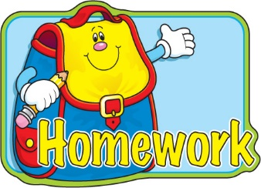
Sign and return this homework sheet along with the Baggy Books on
Friday, April 22nd.
All students who return their homework earn an extra S.T.A.R. ticket.

