Name: _______________________________________
Directions: Check the box once you complete the homework activity. Challenge yourself and complete the two bottom optional activities.
Homework and Baggy Books are due Friday, March 11, 2022

Sight Words  Practice reading your assigned sight words as often as possible. If you are done reading your sight words, work on spelling them!  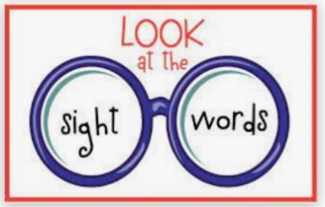 | Word Work  Practice your weekly phonics words. Choose an activity from the phonics choice board.  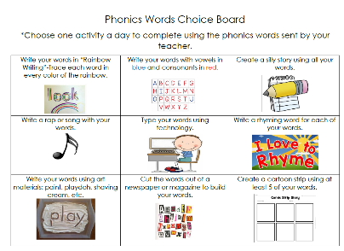  Look on the back for this week’s focus.
Technology Time  Complete at least 20 minutes on Headsprout,  or Dreambox Learning.  This Photo by Unknown Author is licensed under CC BY-SA | Reading  Read your Baggy Books and record them on your Reading Log.
Enrichment – Social Studies  Which hero do you think was most important to our country: Benjamin Franklin, Thomas Jefferson, or Theodore Roosevelt? Write an opinion paragraph stating your opinion and supplying reasons to support your opinion. Don’t forget to include a closing sentence!  O.R.E.O.  State your opinion  Give 3 reasons  Give at least 1 example  Restate your opinion | Kindness Corner-  Exceptional Children’s Week  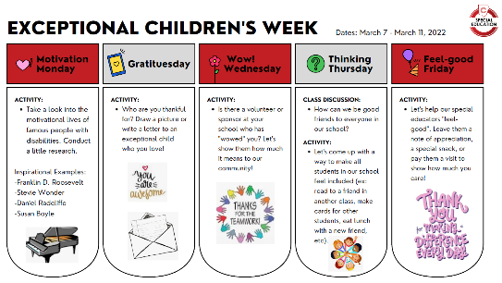  Please complete the FRIDAY activity. Write Ms. Dunn or another teacher (speech, specialist) a note or send in a treat. I happen to know that Ms. Dunn loves Reese’s!

the work as you complete the assignments.
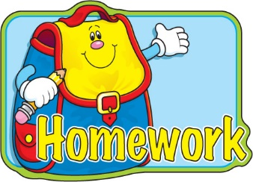
Sign and return this homework sheet along with the Baggy Books on Friday, March 11th.
All students who return their homework earn an extra S.T.A.R. ticket.

