Name: _______________________________________ HOMEWORK
Directions: Check the box once you complete the homework activity. Challenge yourself and complete the two bottom optional activities.
This Homework and Baggy Books are due Friday, April 1, 2022
Sight Words  Practice reading your assigned sight words as often as possible. If you are done reading your sight words, work on spelling them! | Word Work  Practice your weekly phonics words. Choose an activity from the phonics choice board.  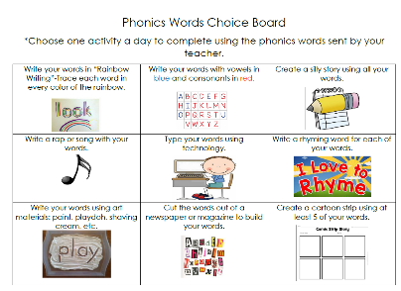  Look on the back for this week’s focus.
Technology Time  Complete at least 20 minutes on Headsprout,  or Dreambox Learning.  This Photo by Unknown Author is licensed under CC BY-SA | Reading  Read your Baggy Books and record them on your Reading Log.
Enrichment – Math Fluency  Practice your addition and/or subtraction facts to 10 to increase fluency. Have a parent play games or give you practice tests to increase your speed. Work with only a few facts at a time until you are fluent. Then move on to a few more facts. You should aim for solving ten facts in one minute! Accept the challenge! You can do it! | College and Career Week  Interview a parent or another adult you know about what job they have. Ask them questions like what kind of schooling did they need to get their job, what do they like best about it, what skills do they use at work, and what other job could they have with those skills? Write who you interviewed along with your questions and their answers. Use correct capitals and ending punctuation!

the work as you complete the assignments.
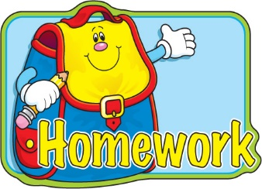
Sign and return this homework sheet along with the Baggy Books on
Friday, April 1st.
All students who return their homework earn an extra S.T.A.R. ticket.

