Name: _______________________________________
Directions: Check the box once you complete the homework activity. Challenge yourself and complete the two bottom optional activities.
Homework and Baggy Books are due Friday, March 25, 2022

Sight Words  Practice reading your assigned sight words as often as possible. If you are done reading your sight words, work on spelling them! | Word Work  Practice your weekly phonics words. Choose an activity from the phonics choice board.  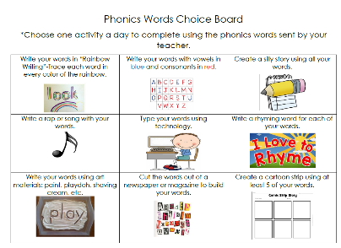  Look on the back for this week’s focus.
Technology Time  Complete at least 20 minutes on Headsprout,  or Dreambox Learning.  This Photo by Unknown Author is licensed under CC BY-SA | Reading  Read your Baggy Books and record them on your Reading Log.
Enrichment – Cooking with Math  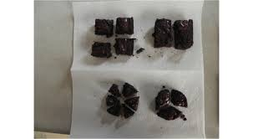  In math, we are working with shapes. We’ll be partitioning circles and rectangles into halves and fourths, as well as exploring equal shares. Decomposing a shape into more equal shares creates smaller shares. Explore these concepts with your child through cooking. Make a pizza or a pan of brownies. Decompose (divide them) into halves then fourths. Discuss what happens to the equal shares. Then, cut them into more equal shares. Discuss what happens to the pieces. Do they get bigger or smaller? Draw a picture or take a photo of your cooking project. | College and Career Week  Starts March 28th  What do you think you would like to do when you grow up?  Research a career you might be interested in and write a paragraph about what you learned. Include the skills you will need to do that job well and then illustrate yourself working.  Don’t forget to use correct capitals and ending punctuation!

the work as you complete the assignments.
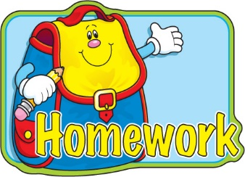
Sign and return this homework sheet along with the Baggy Books on Friday, March 25th.
All students who return their homework earn an extra S.T.A.R. ticket.

