Name: _______________________________________
Directions: Check the box once you complete the homework activity. Challenge yourself and complete the two bottom optional activities.
Homework and Baggy Books are due Friday, March 18, 2022

Sight Words  Practice reading your assigned sight words as often as possible. If you are done reading your sight words, work on spelling them! | Word Work  Practice your weekly phonics words. Choose an activity from the phonics choice board.  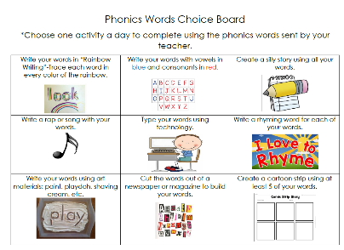  Look on the back for this week’s focus.
Technology Time  Complete at least 20 minutes on Headsprout,  or Dreambox Learning.  This Photo by Unknown Author is licensed under CC BY-SA | Reading  Read your Baggy Books and record them on your Reading Log.
Enrichment – Science  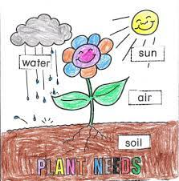  We will be starting a unit about plants next week. Research what plants need to stay alive. Create a poster, song, poem, or book showing plant needs. Be creative! | Family Fun! – Shape HUNT!  We will be starting a unit on shapes in math next week. DO a shape hunt at your house. How many of each shape can you find? Make a chart or graph to collect and share your data.  Look for the following shapes at home:  Circle, Square, Rectangle, Triangle, Hexagon, Pentagon  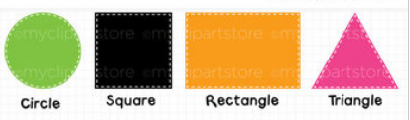

the work as you complete the assignments.
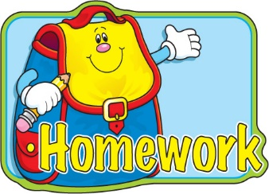
Sign and return this homework sheet along with the Baggy Books on Friday, March 18th.
All students who return their homework earn an extra S.T.A.R. ticket.

