Name: _______________________________________
Directions: Check the box once you complete the homework activity. Challenge yourself and complete the two bottom optional activities.
Homework and Baggy Books are due Friday, February 18, 2022

Sight Words  Practice reading your assigned sight words as often as possible. If you are done reading your sight words, work on spelling them! | Word Work  Practice your weekly phonics words. Choose an activity from the phonics choice board.  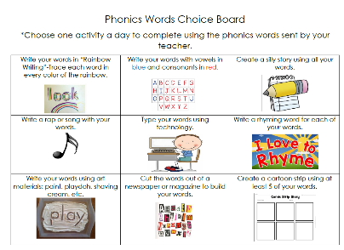  Look on the back for this week’s focus.
Technology Time  Complete at least 20 minutes on Headsprout,  or Dreambox Learning.  This Photo by Unknown Author is licensed under CC BY-SA | Reading  Read your Baggy Books and record them on your Reading Log.
Enrichment – Math Challenge  Complete the following word problems. Remember to use numbers, pictures, and words to show your thinking. Include an equation and solution too!  - There were 15 bees flying. Some of them flew into the hive. There were 5 left. How many bees flew into the hive?  - 13 students are eating snack but there are only 5 napkins. How many more napkins are needed so that each student has one to use? | Kindness Corner  Bring $1 for charity and wear your pajamas on Friday. All proceeds will benefit CCYA- The Center for Children and Youth Adults!

the work as you complete the assignments.
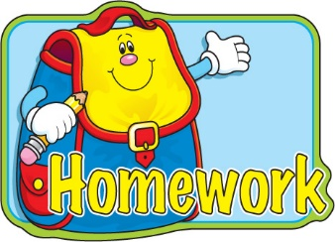
Sign and return this homework sheet along with the Baggy
Books on Friday, February 18th. All students who return their homework earn an
extra S.T.A.R. ticket.

