Name: _______________________________________
Directions: Check the box once you complete the homework activity. Challenge yourself and complete the two bottom optional activities.
Homework and Baggy Books are due Friday, January 14 , 2022

Sight Words  Practice reading your assigned sight words as often as possible. | Word Work  Practice your weekly phonics words. Choose an activity from the phonics choice board.  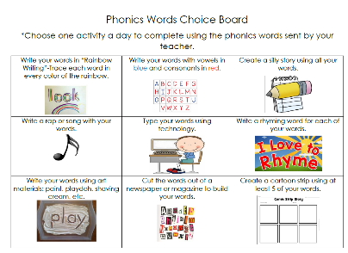  Look on the back for this week’s focus.
Technology Time  Complete at least 20 minutes on Headsprout,  or Dreambox Learning.  This Photo by Unknown Author is licensed under CC BY-SA | Reading  Read your Baggy Books and record them on your Reading Log.
Enrichment- Social Studies  We will soon be learning about Lewis and Clark with Sacagawea. Research these historical figures and create a poster or book about their important accomplishments. Be ready to share what you learned with the class! | Kindness Corner  Donate to the Towel Drive!  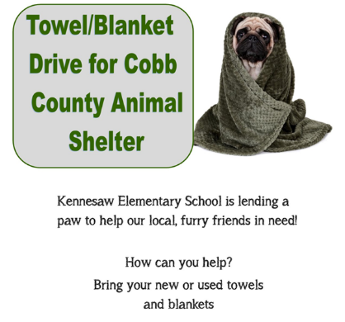

the work as you complete the assignments.
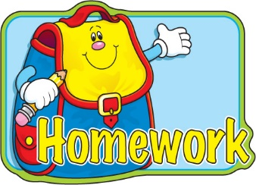
Sign and return this homework sheet along with the Baggy
Books on Friday, January 14th. All students who return their homework earn an
extra S.T.A.R. ticket.

