Name: _______________________________________
Directions: Check the box once you complete the homework activity. Challenge yourself and complete the two bottom optional activities.
Homework and Baggy Books are due Friday, February 4, 2022

Sight Words  Practice reading your assigned sight words as often as possible. If you are done reading your sight words, work on spelling them! | Word Work  Practice your weekly phonics words. Choose an activity from the phonics choice board.  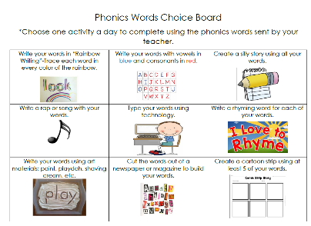  Look on the back for this week’s focus.
Technology Time  Complete at least 20 minutes on Headsprout,  or Dreambox Learning.  This Photo by Unknown Author is licensed under CC BY-SA | Reading  Read your Baggy Books and record them on your Reading Log.
Valentine Exchange  We will be exchanging Valentines on Monday, February 14th. Begin decorating a valentine box. Make sure that you can take the lid off your box and that it is big enough to fit valentines with candy from 18 students. Have fun!  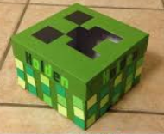 | Kindness Corner  This Valentine’s Day, our class has adopted a Resident at Kennesaw Place to show some KES love to!  Our Resident is: Janet Bauder  Refer to the sheet that was sent home for ideas on some of her favorite items.  Please consider donating items  by Wednesday, Feb. 9th.  Thanks so much for your support!

the work as you complete the assignments.
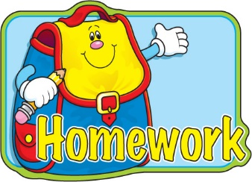
Sign and return this homework sheet along with the Baggy
Books on Friday, February 4th. All students who return their homework earn an
extra S.T.A.R. ticket.

