Name: _______________________________________
Directions: Check the box once you complete the homework activity. Challenge yourself and complete the two bottom optional activities.
Homework and Baggy Books are due Friday, January 21 , 2022

Sight Words  Practice reading your assigned sight words as often as possible.  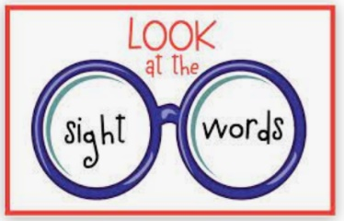 | Word Work  Practice your weekly phonics words. Choose an activity from the phonics choice board.  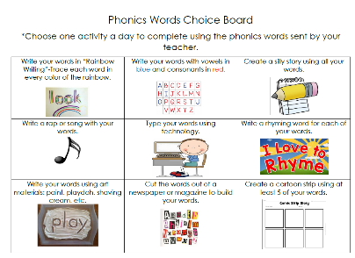  Look on the back for this week’s focus.
Technology Time  Complete at least 20 minutes on Headsprout,  or Dreambox Learning.  This Photo by Unknown Author is licensed under CC BY-SA | Reading  Read your Baggy Books and record them on your Reading Log.
Enrichment- Writing  What is the best (or worst) food?  Write your opinion about it.  Include your topic sentence (stating the food and how you feel about it).  Then, give some reasons for why you feel this way. Try to use examples from your experience with it to support your opinion.  Finally, write a closing sentence that tells your feeling about the food again or tries to convince us to eat (or not eat) it.  Don’t forget to write complete sentences, use capital letters, and correct ending punctuation! | Kindness Corner  Be kind to yourself!  We just finished our healthy habits unit, and a free toothbrush came home yesterday.  Keep a Healthy Habits chart (attached).  See how many items you can check off in a week!

the work as you complete the assignments.
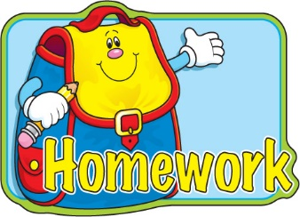
Sign and return this homework sheet along with the Baggy
Books on Friday, January 21st. All students who return their homework earn an
extra S.T.A.R. ticket.

