Name: _______________________________________
Directions: Check the box once you complete the homework activity. Challenge yourself and complete the two bottom optional activities.
Homework is due Friday, Nov. 12th, 2021.
Sight Words  Practice reading your assigned sight words as often as possible. | Word Work  Practice your weekly phonics words. Choose an activity from the phonics choice board.  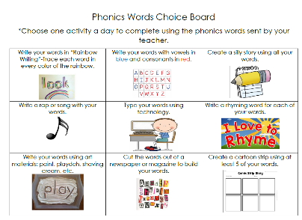  Look on the back for this week’s focus.
Technology Time  Complete at least 20 minutes on Headsprout,  Moby Max or Dreambox Learning.  This Photo by Unknown Author is licensed under CC BY-SA | Reading  Read your Baggy Books and record them on your Reading Log.
NUTRITION  Take the 5-A-Day Challenge!  Use the chart sent home to keep track of the fruits and vegetables eaten for a week.  Write down in each box what fruit or veggie you had – at home and at school.  Can you meet the challenge? | CANNED FOOD DRIVE  Can you please help us make a difference? We’re trying to make holiday meals for some local families in need. They’ll be donated to the food pantries at Fair Oaks and Belmont Hills Elementary Schools.  Pease consider donating the following:  canned foods, pasta, rice, and/or instant potatoes. Diapers are also needed.  Thanks in advance for your generosity!
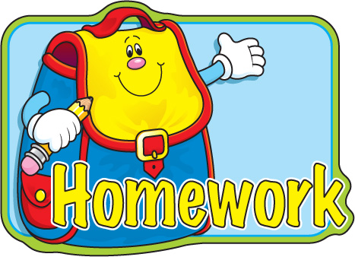
the work as you complete the assignments.
Sign and return this homework sheet along with the Baggy
Books on Friday, November 12. All students who return their homework earn an
extra S.T.A.R. ticket.

